JOB POSTING: WIC BREASTFEEDING PEER HELPER

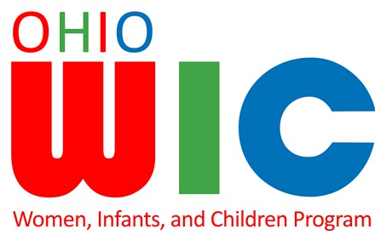

Jackson County WIC is hiring an experienced Breastfeeding Mom
to provide basic breastfeeding information & support to new moms.
Position is part-time/full-year & applicants must pass a drug & background check. Starting wage is $10.50/hour.

Job Qualifications:
- Exclusively breastfed your baby at least 6 months or longer, within the last five years
- Enthusiastic about breastfeeding
- Willing to talk with other WIC Moms about your experiences
- Creative and tech savvy
- Able to work 20 hours/week

WIC would like to talk with You!

Visit the Jackson-Vinton Community Action website at: www.jvcai.org to complete and print an employment application or stop by the Jackson County WIC Office at 73-A East Huron Street, Jackson to pick one up. Drop off your completed application at the WIC Office, or JVCAI at 118 S. New York Ave., Wellston, OH 45692 by the deadline date of February 19, 2021 by 4:30 pm.

YOU could be the one to assist with Moms helping Moms!

JVCAI is an Equal Opportunity Provider

